**INTELLIGENT CUSTOMER RETENTION: USING MACHINE LEARNING FOR ENHANCED PREDICTION OF TELECOM CUSTOMER CHURN**

**TEAM LEADER : MENTOR :**

**Sabithra M Dr.E.Elakkiya M.sc,M.phil.,Ph.D.,**

**TEAM MEMBERS :**

**V.Santhiya**

**A.Shanmugapriya**

**K.Sharmila**

**1. INTRODUCTION**

The primary goal of this work to investigate how huge machine learning data platforms may be used to anticipate customer attrition in the telecom industry. The likelihood that a customer will leave a business has been estimated using machine learning techniques. Using several churn prediction datasets, the performance of the proposed model is assessed. Several measures, including accuracy, precision, recall, and f-measure, are used to assess the suggested churn prediction model. The goals of the proposed study include locating problems with the existing survey, offering a useful model for customer churn prediction, and accurately identifying churners. After that, the probable churners could be given the retention strategies. Also, it was noted from the tests that the suggested churn prediction model outperformed its competitors in terms of churn prediction by obtaining.

* 1. **Overview**

Customer attrition, also called consumer defection, or customer churn, describes the rate at which customers are lost. Customer churn is a major problem and one of the main topics for big businesses. Attributing to the direct influence on companies' retirement savings, primarily in the telecommunications industry, Providers are developing to provide methodologies of estimating the probability that a customer will abandon. When something concerns to constructive dismissal, customers might do that for a number of different reasons, involving better price offers, more interesting packages, bad customer interrelations, or adjustments in their unique factors. Customer churn seems to have been a priority for organizations due to the rising management competition, the importance of traditional marketing, and customers' increasingly aware behaviour in recent years.

Alternative services can easily are becoming more accepted by customers. Depending on the services they offer, commercial enterprises must create customized management techniques for some of these dangerous trends. Data from the current churns can also be used to analyze the potential churns. A competent churn framework supports economic growth in countless ways. Early detection of customers for being probable quitters might help establish cost-effective marketing strategies. Campaigns to satisfy customer might still attack a subgroup of customers, nevertheless they ought to attack the large percentage of customers. Factually incorrect weather predictions could cause a company to decline in value because of the discounts presented to surprisingly common subscribers.

When one industry offers a better plan than the previous one, there is a high possibility that perhaps the customer would therefore start leaving the existing strategy in furtherance of the better plan. In such a scenario, it is very difficult to avoid losses, but through prediction we can keep it to a reasonable level.

Customer churn has been extensively utilized by numerous telecom enterprises as an important business metric to accurately predict the number of customers out there that will transition telecom service wireless carriers. In addition to identifying the customers who were the most inclined to leave, a machine learning model was utilized.

**1.2 Purpose**

The primary goal of the work how huge machine learning data platforms may be used to anticipate customer attrition in the telecom industry .The likelihood that a consumer will leave a business has been estimated using machine learning algorithms.

Churn analysis can identify high-risk consumers and assist in retaining them by assisting in understanding what reasons drive your customers to depart. Last but not least, consumer retention will increase, and profitability will be bigger than before.

Businesses can prevent churn by taking preventative measures when they can anticipate it before it occurs. Customer success teams could approach those high-risk clients to offer assistance or determine what needs might not be being addressed.

Data analytics are required at every stage, whether they occur offline or during runtime, for purposes such as suggestion, prediction, security monitoring, and so forth. Diagnostic analytics, predictive analytics, descriptive analytics, outcome analytics, and prescriptive analytics are included in its fi Firms must accurately predict customer behaviour, strengthen the link between consumer attrition and should have variables within their control in order to reduce consumer turnover.

**2. Problem Definition & Design Thinking**

**2.1 Empathy Map**

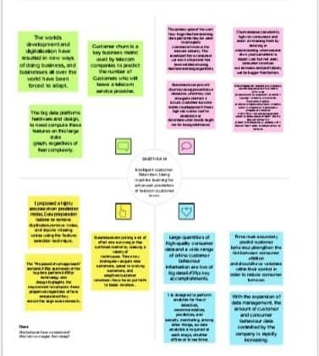

**2.2 Ideation & Brainstorming Map**



**3.Result**

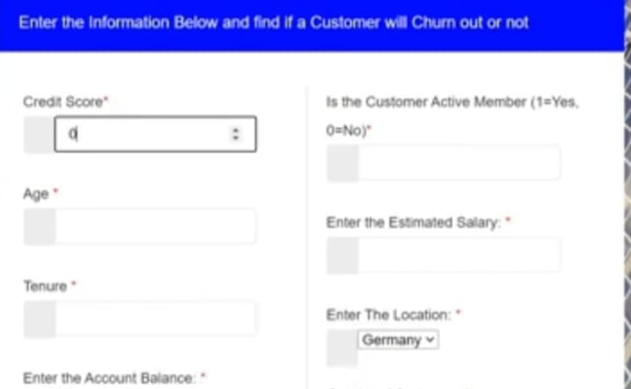

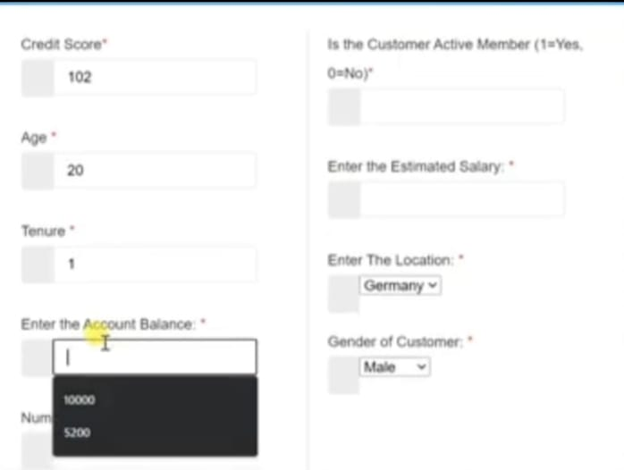

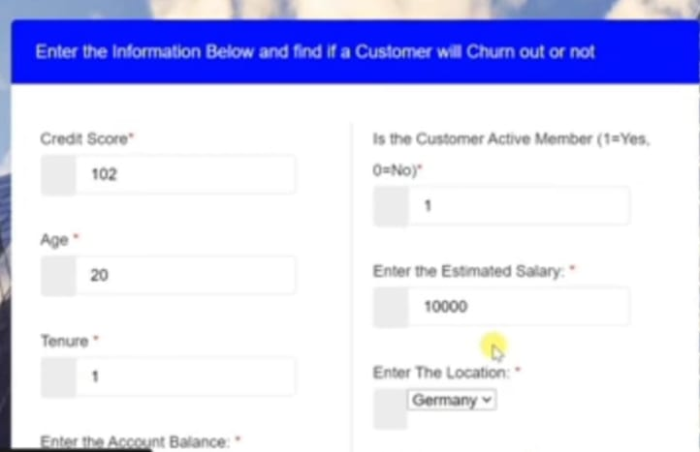

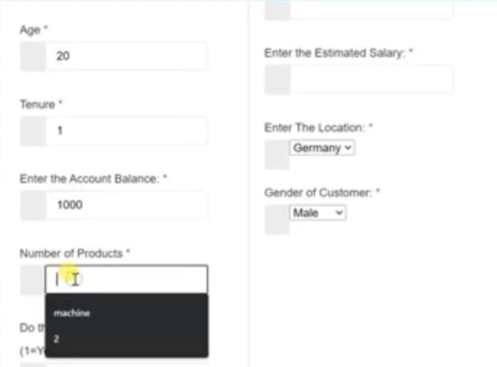

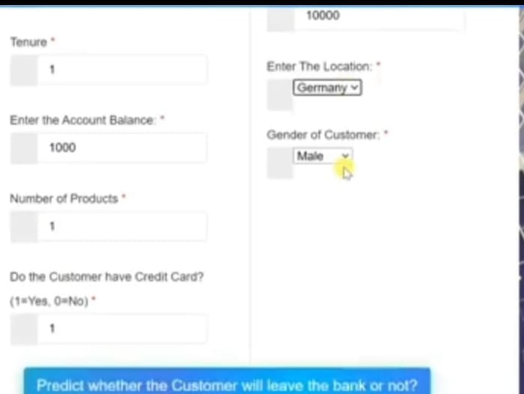

**4.Advantages & Disadvantages**

**Advantages :**

Customer churn analysis aids firms in understanding the reasons why consumers don't come back for more. Churn rate reveals what percentage of your clients leave over time. Examining churn by product, location, or other specific reasons is frequently beneficial.

**Disadvantages :**

As a result, your prospects of growing your firm are reduced the greater your client churn rate. The cost of getting new consumers is so expensive that losing clients causes your bottom line to suffer, even if you have some of the best marketing strategies in your sector.

**5. Application**

Data mining can be used, among other things, to predict client attrition. One of the main issues in markets like banks where there is intense rivalry is customer churn, which is the usual metric of lost clients.

Churn prediction is the process of identifying which consumers are most likely to stop using a service or to cancel their subscription. Because getting new customers frequently costs more than keeping existing ones, it is an important prediction for many firms.

**6.Conclusion**

My company, which is in the telecom industry, will benefit greatly from the impact of Chum's prediction and grow its income. The biggest problem in the telecom industry is customer retention, and as a result, many organisations want to keep their current customers rather than incurring more expenses. We selected three ree-heel algorithms due to their versatility and diversity in this type of application. We will obtain a comparison of the accuracy and precision using Raido Forest XBoost and logistic regression. In order to score the pay services, HP S Kernity Theaters will use a dataset of my customers' service plans to assess their vulnerability and make predictions. Consequently, the Telecom Company

**7. Future Scope**

By looking for patterns in a set of input data, predictive modelling uses mathematics to foretell future events or results. It is an essential part of predictive analytics, a sort of data analytics that makes use of both recent and old data to predict activity, behaviour, and trends**.**

Utilising past data, predictive analytics forecasts future events. Typically, a mathematical model that captures significant trends is constructed using historical data. Then, using the most recent data, this predictive model is applied to forecast future events or to recommend course of action for the best possible results.

**8. Appendix**

**A. Source Code**



